- Miro Project Planning
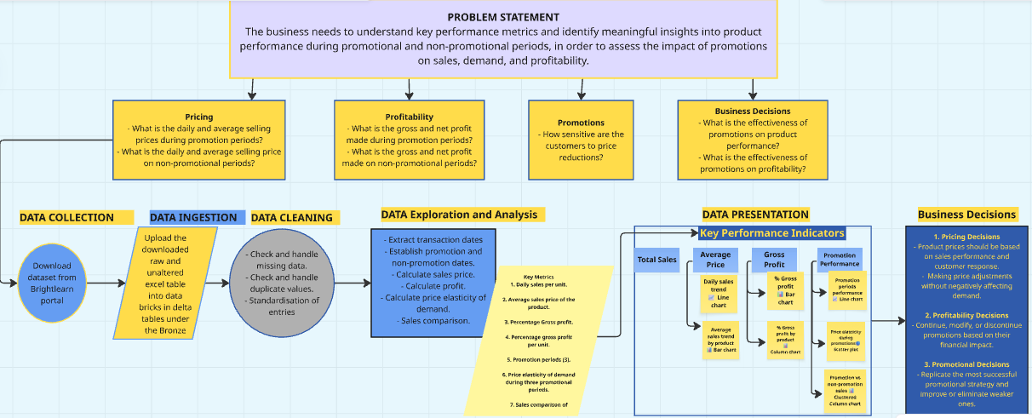

Miro link: https://miro.com/app/board/uXjVHxX6UM4=/?share_link_id=937454978528

